ONLINE RESOURCE 1

CARBON EXPORT IS FACILITATED BY SEA URCHINS TRANSFORMING KELP DETRITUS

Karen Filbee-Dexter^{1,2}, Morten Foldager Pedersen³, Stein Fredriksen^{4,1}, Kjell Magnus Norderhaug¹, Eli Rinde², Trond Kristiansen², Jon Albretsen¹, Thomas Wernberg^{3,5}

1. Institute of Marine Research, His, Norway
2. Norwegian Institute for Water Research, Oslo, Norway
3. Department of Science and Environment, Roskilde University, Roskilde, Denmark.
4. University of Olso, Oslo, Norway
5. UWA Oceans Institute and School of Biological Sciences, University of Western Australia, Crawley, Australia

Regional Ocean Modeling System
ROMS is a state-of-the-art, three-dimensional, free-surface, hydrostatic, primitive equation ocean model that uses generalized terrain-following coordinates to define the vertical axis (i.e., the water column). The hydrodynamic equations are solved in a structured manner using a vertically and horizontally defined grid structure. For our study area, the total model area encapsulated Malangen fjord and its adjacent fjords and had a 160 m x 160 m horizontal resolution and a 35-layer vertical resolution (thus the height of each layer depends on the depth of the water column; smallest at shallow depths where the 35 layers are the most compressed, and highest at deepest depths). The 1st layer began at the surface and the 35th layer ended at the seafloor. In each cell of the resulting 3D grid, the model calculated ocean current, salinity, and temperature every hour for a year period. The open boundary forcing required to run the hydrodynamic model (i.e., the wind, tide, wave, and river run-off data from a larger area of ocean that influenced our study area) were obtained from the AROME Meteorological Co-operation on Operational Numerical Weather Prediction (MetCoOp; atmospheric forcing at 2.5 km resolution) (Müller et al. 2017), the NorKyst800 ocean model (Albretsen et al., 2011, ocean forcing at 800m x 800m resolution), and the Norwegian Water Resources and Energy Directorate (run-off data from real-time river discharges). Both NorKyst800 and MetCoOp were run operationally at the Norwegian Meteorological Institute. The hydrodynamics experienced at the individual kelp particle location were interpolated spatially and temporally to the exact location and time.
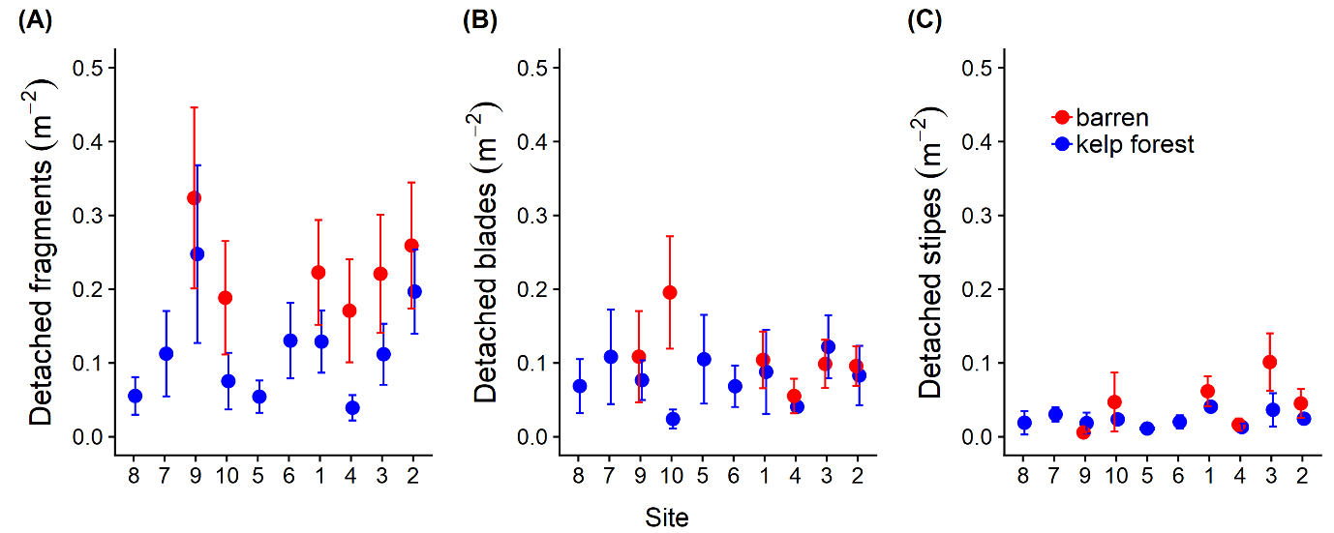
Fig S1. Density of detrital fragments (A), blades (B), and stipes (C) observed in kelp forest and barrens sites (ordered by increasing sea urchin densities in kelp forests). Average (± SE) across sampling period
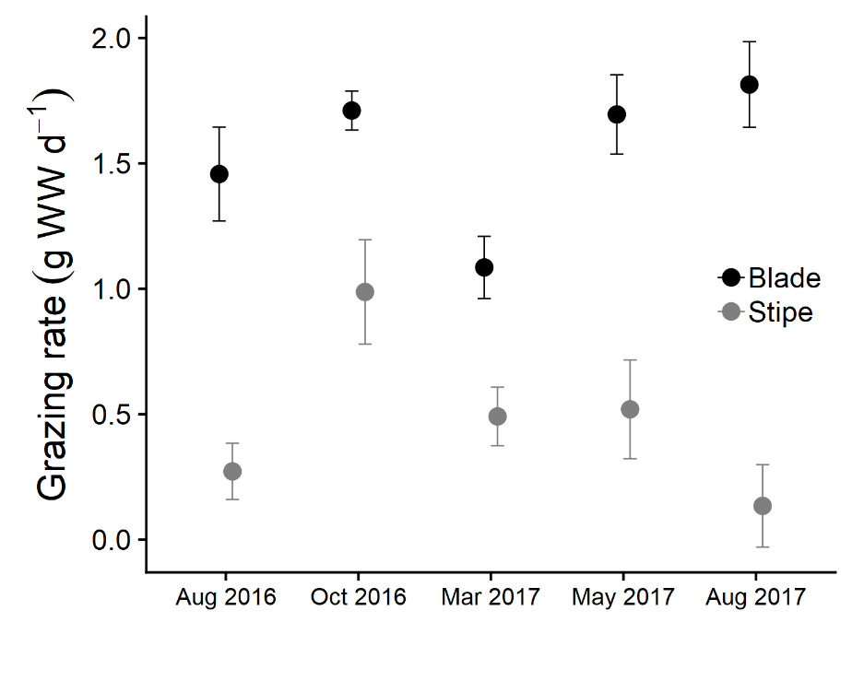
Fig S2. Temporal pattern in measured grazing rates on kelp detritus deployed at the sheltered control site over 5 time periods. Results are averages (± SE) for blade and stipe particles, pooled over tethered treatment (particle attached to end of 0.2 m line of fishing twine) and untethered treatment (particle attached to chain)

